Add Icons in HTML
Icons are small graphical symbols used in web pages to represent actions, features, or information. Examples include home, search, user, settings, heart, menu, email, and social-media icons.

1. Ways to Add Icons in HTML
There are several common ways to add icons:
- Unicode characters / HTML entities
- Emoji
- Font Awesome
- Google Material Icons
- SVG icons
- Image icons
- Icon libraries/packages

2. Using Unicode / HTML Entities
HTML provides entities that can be used as symbols.
<p>&copy; 2026</p><p>&hearts; Love</p><p>&check; Completed</p>
Example:
<h2>&#9733; Rating</h2>
Output:
★ Rating

Advantages
- No external library required
- Simple to use
- Lightweight

Disadvantages
- Limited icon selection
- Styling and consistency can be difficult

3. Using Emoji
Modern browsers support emojis directly in HTML.
<h2>🏠 Home</h2><p>📧 Email</p><p>📞 Contact</p><p>❤️ Like</p>
You can also use emojis inside buttons:
<button>🔍 Search</button><button>🛒 Cart</button>

Note
Emoji appearance can vary between operating systems and browsers.

4. Font Awesome Icons
Font Awesome is one of the most commonly used icon libraries.
It provides icons for:
- Home
- Search
- User
- Settings
- Email
- Phone
- Social media
- Arrows
- Shopping cart
- Many other UI elements
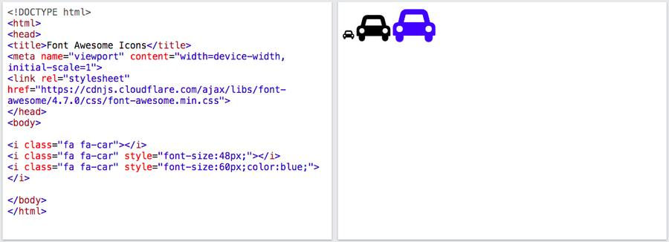
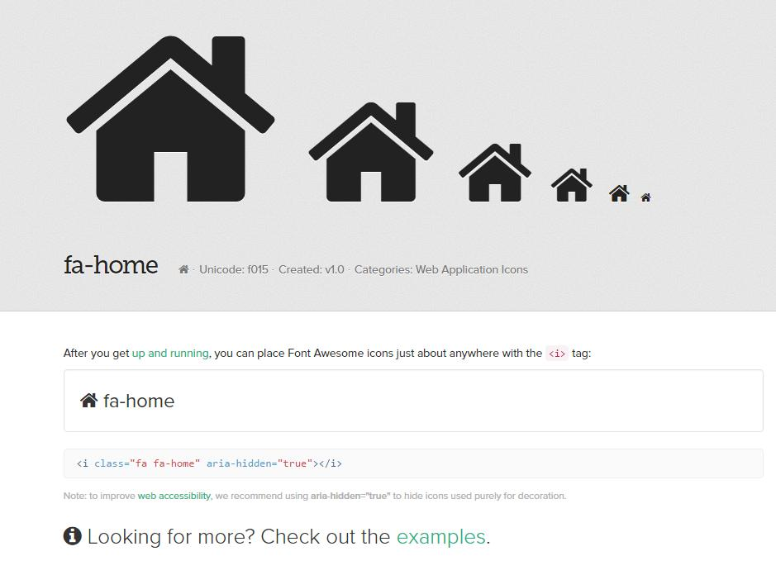
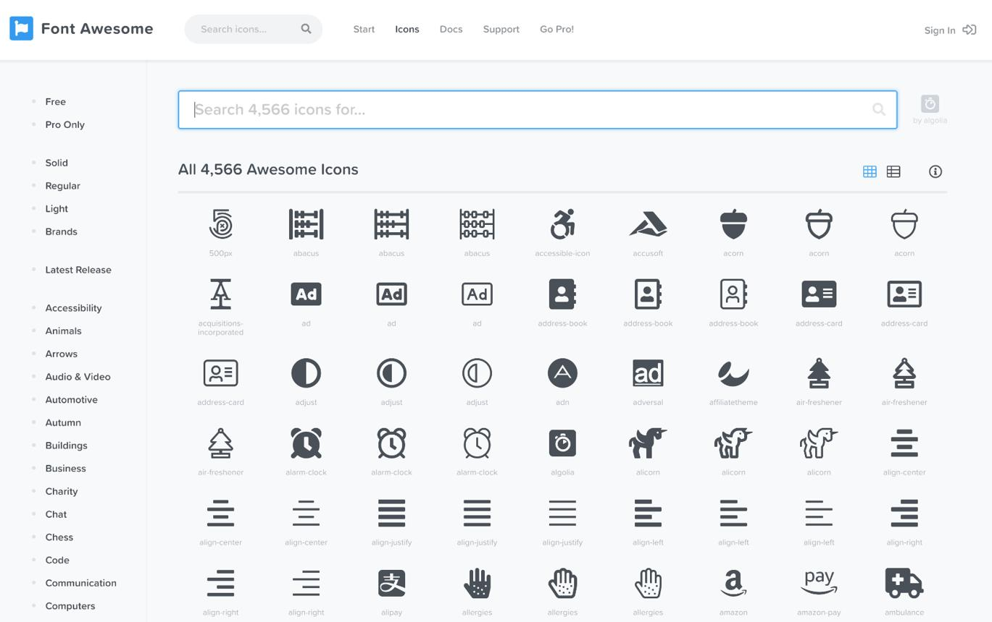
5

Step 1: Include Font Awesome
You can include Font Awesome using a CDN.
<head>
<link
rel="stylesheet"
href="https://cdnjs.cloudflare.com/ajax/libs/font-awesome/6.5.1/css/all.min.css"
></head>

Step 2: Add an Icon
<i class="fa-solid fa-house"></i>
Example:
<h2>
<i class="fa-solid fa-house"></i>
Home</h2>

5. Common Font Awesome Icons

Home
<i class="fa-solid fa-house"></i>

User
<i class="fa-solid fa-user"></i>

Search
<i class="fa-solid fa-magnifying-glass"></i>

Settings
<i class="fa-solid fa-gear"></i>

Heart
<i class="fa-solid fa-heart"></i>

Email
<i class="fa-solid fa-envelope"></i>

Phone
<i class="fa-solid fa-phone"></i>

Shopping Cart
<i class="fa-solid fa-cart-shopping"></i>

6. Styling Font Awesome Icons with CSS
Icons can be styled just like normal HTML elements.
<i class="fa-solid fa-heart heart-icon"></i>
.heart-icon {
font-size: 30px;
color: red;
}

Common properties
.icon {
font-size: 24px;
color: blue;
margin: 10px;
}

7. Icons Inside Buttons
Icons are commonly used with buttons.
<button>
<i class="fa-solid fa-download"></i>
Download</button>
Another example:
<button>
<i class="fa-solid fa-trash"></i>
Delete</button>

8. Icons Inside Links
<a href="#">
<i class="fa-solid fa-house"></i>
Home</a>
Navigation example:
<nav>
<a href="#">
<i class="fa-solid fa-house"></i> Home
</a>

<a href="#">
<i class="fa-solid fa-user"></i> Profile
</a>

<a href="#">
<i class="fa-solid fa-envelope"></i> Messages
</a></nav>

9. Google Material Icons
Google provides Material Icons that can be added to web pages.
Include the icon font:
<link
href="https://fonts.googleapis.com/icon?family=Material+Icons"
rel="stylesheet">
Use an icon:
<span class="material-icons">home</span>
Example:
<button>
<span class="material-icons">search</span>
Search</button>

10. Using SVG Icons
SVG is another popular way to add icons.
SVG icons are useful because they can be:
- Scaled without losing quality
- Styled using CSS
- Customized
- Used without a font library

11. Using an Image as an Icon
An image can also be used as an icon.
<img src="home-icon.png" alt="Home">
CSS:
img {
width: 24px;
height: 24px;
}
For simple UI icons, SVG or icon libraries are generally more flexible than raster images.

12. Icon as a CSS Background
An image can also be used as a background.
<div class="home-icon"></div>
.home-icon {
width: 30px;
height: 30px;
background-image: url("home.png");
background-size: contain;
background-repeat: no-repeat;
}

13. Icon Libraries
Popular icon libraries include:
Library | Example
Font Awesome | fa-solid fa-house
Material Icons | home
Bootstrap Icons | bi bi-house
Heroicons | SVG-based
Lucide | SVG-based
Remix Icon | ri-home-line

14. Accessibility for Icons
When an icon communicates important information, make sure its meaning is available to users of assistive technologies.
For a decorative icon:
<i class="fa-solid fa-heart" aria-hidden="true"></i>
For an icon button:
<button aria-label="Search">
<i class="fa-solid fa-magnifying-glass" aria-hidden="true"></i></button>
Here, aria-label provides an accessible name for the button.

15. Complete Font Awesome Example
<!DOCTYPE html><html><head>
<title>Icons Example</title>

<link
rel="stylesheet"
href="https://cdnjs.cloudflare.com/ajax/libs/font-awesome/6.5.1/css/all.min.css"
>

<style>
.icon {
font-size: 25px;
margin-right: 8px;
}
</style></head>
<body>

<h2>
<i class="fa-solid fa-house icon"></i>
Home
</h2>

<button>
<i class="fa-solid fa-magnifying-glass icon"></i>
Search
</button>

<button>
<i class="fa-solid fa-user icon"></i>
Profile
</button>

<button>
<i class="fa-solid fa-trash icon"></i>
Delete
</button>
</body></html>

16. Quick Comparison
Method | External Library | Customizable | Common Use
Unicode | No | Limited | Simple symbols
Emoji | No | Limited | Casual UI
Font Awesome | Yes | Yes | Web applications
Material Icons | Yes | Yes | Google-style UI
SVG | No | Very high | Modern UI
Image | No | Medium | Custom icons

Key Points for Interviews
- Font Awesome is a popular icon library for web applications.
- Icons can be added using icon libraries, SVG, images, Unicode, or emoji.
- Font Awesome icons are commonly added using <i> elements with CSS classes.
- Icons can be styled using normal CSS properties such as font-size, color, and margin.
- Use aria-label for icon-only interactive elements.
- Use aria-hidden="true" for decorative icons.
- SVG provides excellent scalability and customization.

